AI-ASSISTED CODING
ASSINGMENT-13.4

A.GOUTHAMI
2303A53040
BATCH-46

Task 1: Refactoring Data Transformation

PROMPT:
CODE:
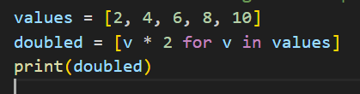

OUTPUT:

Task 2: Improving Text Processing Code Readability

PROMPT:
CODE:
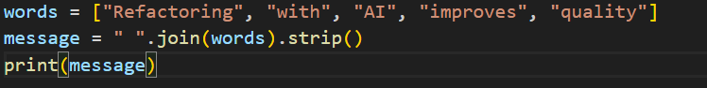
OUTPUT:

Task 3: Safer Access to Configuration Data

PROMPT:
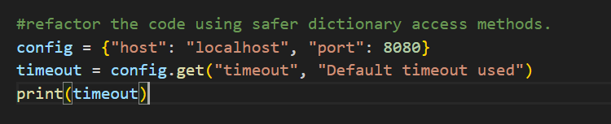
CODE:
OUTPUT:


Task 4: Refactoring Conditional Logic for Scalability
PROMPT:
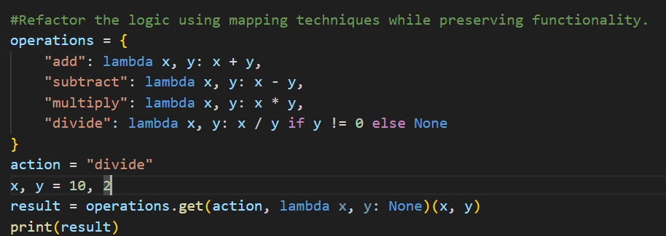

CODE:

OUTPUT:

Task 5: Simplifying Search Logic in Collections
PROMPT:
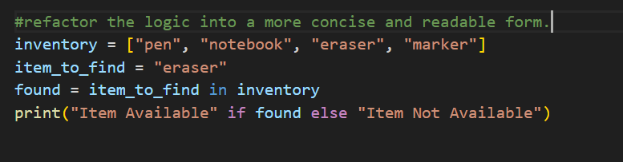

CODE:
OUTPUT:
